# Docker Assignment-2

# Save the image created in assignment 1 as a Docker image

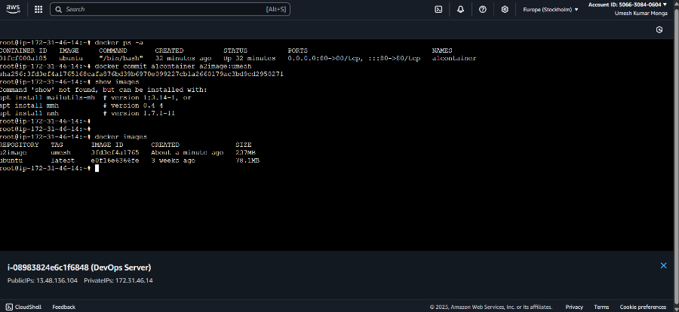

# Launch container from this new image and map the port to 81

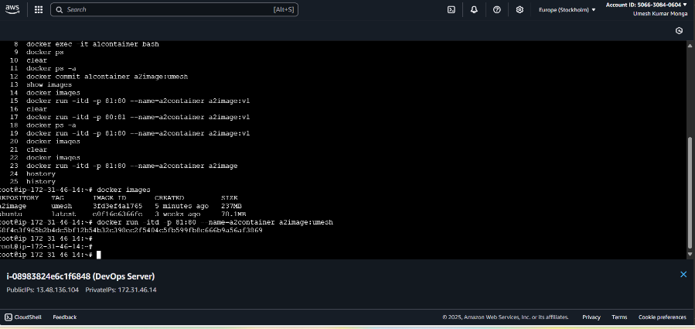

# Go inside the container and start the Apache2 service

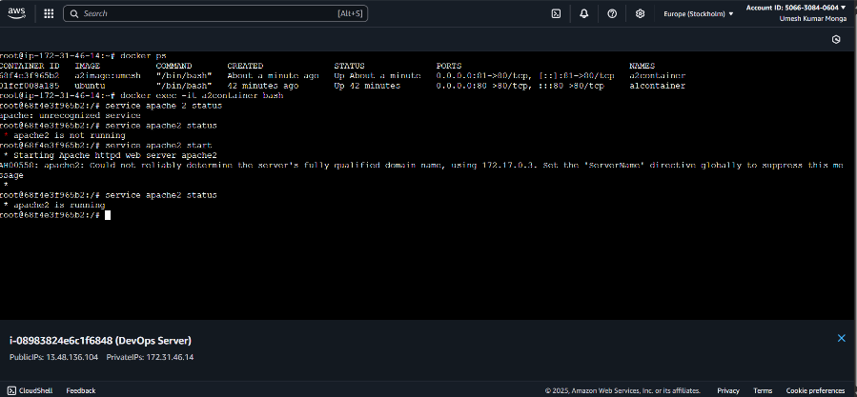

# Check if you are able to access it on the browser

